***Project Report***

***Digital Logic Design***

***Name : Poorab Gangwani***

***Class : 2B***

***Subject : Digital Logic Design***

***Roll-Number : CS191092***

***Software Used : Multisim***

Project subjects:

1. Addition using Full Adder
2. Even Parity Generator
3. Odd Parity Generator
4. Code Conversion (Gray to Binary)
5. Code Conversion (Binary to Gray)

***1)Addition using Full Adder***

In this circuit , I have implemented logic gate ICs of XOR and AND along with LEDs for the implementation and execution of this circuit. In this circuit, we will input 2 4-bit binary numbers and will receive the addition output.

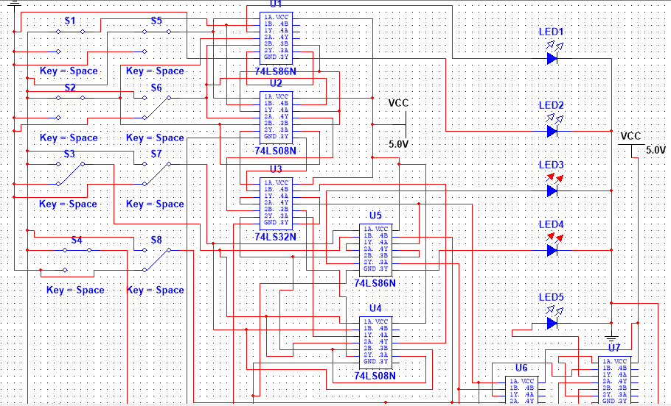

***2)Even Parity Generator***

In this circuit program, I have made use of logic gate IC XOR and have also implemented 7-segment display for the working of this circuit. In this circuit we can input a 4 bit binary number and the display will determine whether it has even number of 1s and if it does then it will showcase the result in accordingly and if it lacks even parity then it will display the input numbers in a way that will contain even parity.

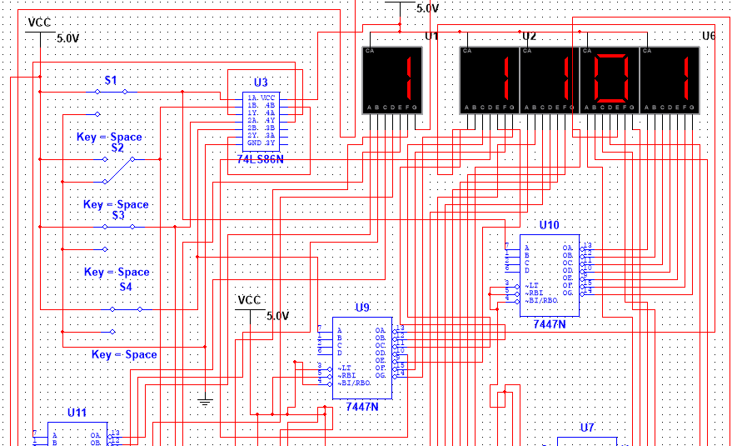

***3)Odd Parity Generator***

In this circuit program, I have applied the XNOR gate IC and 7-Segment Display and I have programmed the circuitry in a manner where it will take input of a 4 bit binary number and will determine whether the input lacks or contains odd parity. if the input does not possesses odd parity , then it display output of number with odd parity.

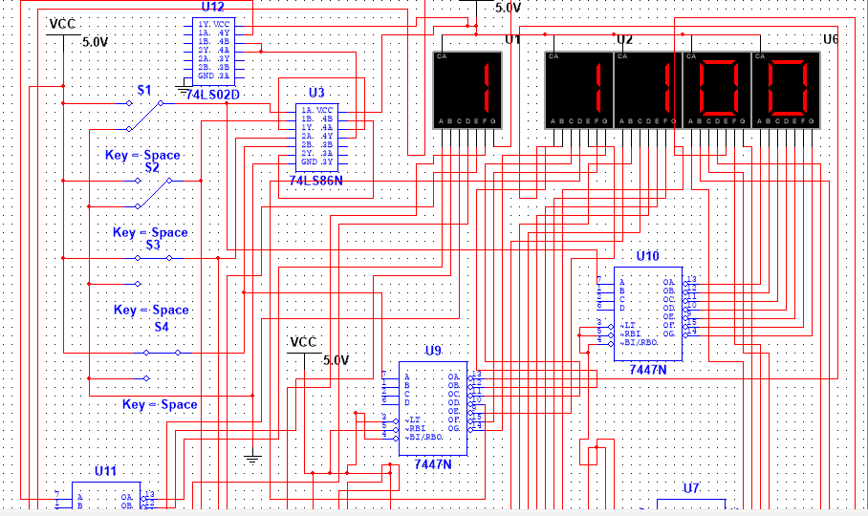

***4) Gray to Binary Converter***

This circuit program contains components like LED and IC of XOR gate and it will function in a manner where it will take gray code Number as input and display it’s binary equivalent on 7 segment display.

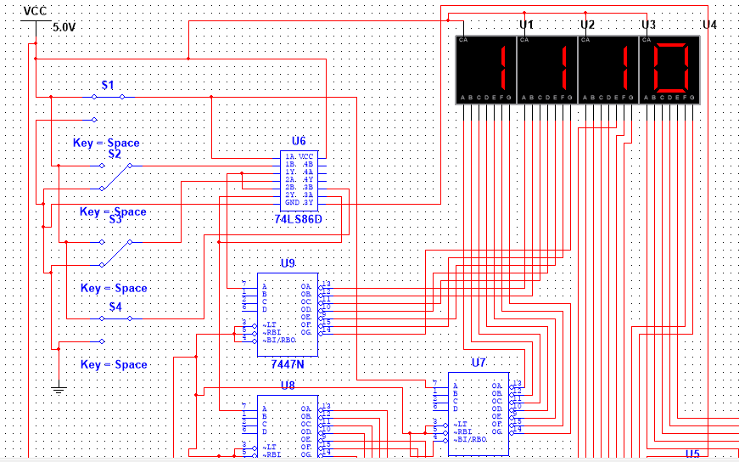

***5) Binary to Gray Converter***

This circuit program is similar to gray to binary converter but differs in the aspect that we will input binary number and it will display it’s gray code equivalent on a 7-Segment Display.

